The Clifton Pavilion Room Set Up with Social Distancing

Table of Content:

Page 2 – Members Room

Page 3 – Council Room

Page 4-11 – Garden Room

Page 4 – Theatre Style
Page 5 – Classroom
Page 6 - Boardroom
Page 7 – U Shape
Page 8 – Cabaret Style
Page 9 – Banqueting (2sqm)
Page 10 – Banqueting (1sqm)
Page 11 – Banqueting Family Group

Page 12-18 – Clifton Suite

Page 12 – Cabaret Style (2sqm)
Page 13 – Cabaret Style (1sqm)
Page 14 – Banqueting
Page 15 – Wedding Ceremony
Page 16 – Wedding Ceremony Continued
Page 17 – Wedding Breakfast Distanced
Page 18 – Wedding Breakfast Family Group

Members Room
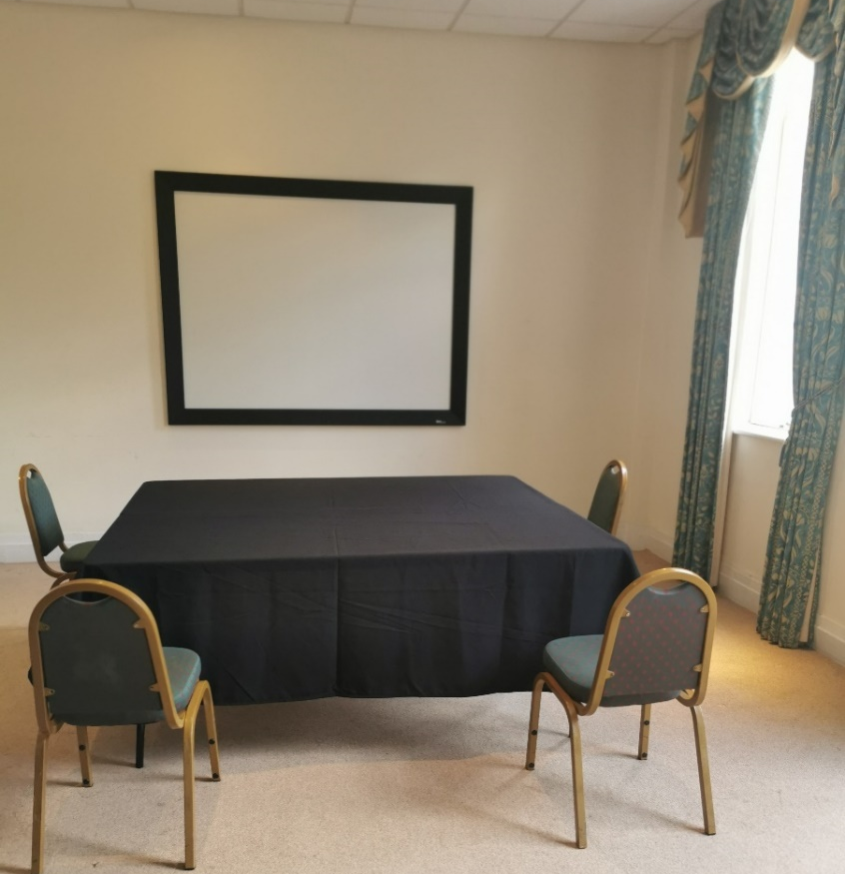
- Boardroom style.

- 4 attendees.

- AV equipment on table.

- Refreshments station in the foyer.

- One-way entry and exit through single access door.

- 1 sqm distancing.

(room is too small for 2sqm distancing)

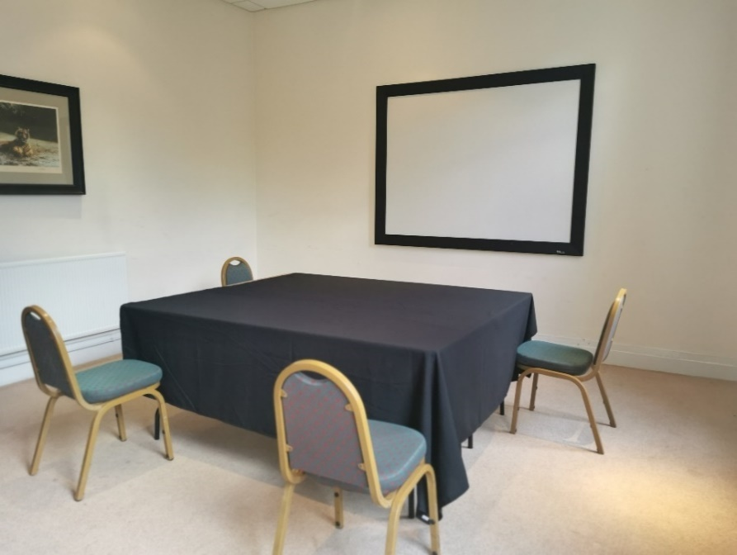

Council Room

- Refreshments station moved to the landing.

- One-way entry and exit through single access door.

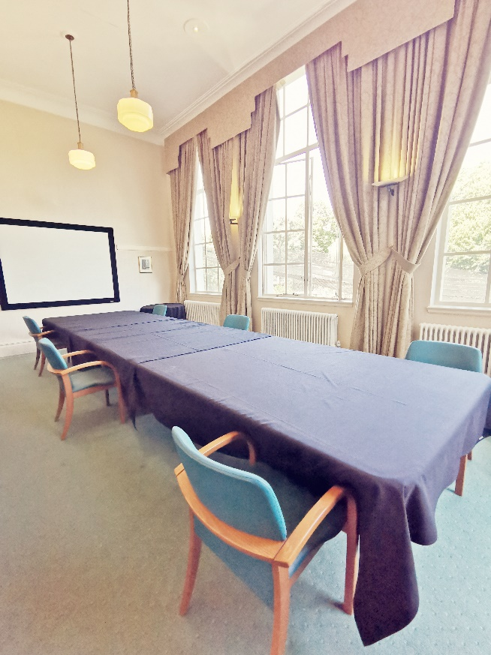
- 2sqm distancing – 6 attendees.

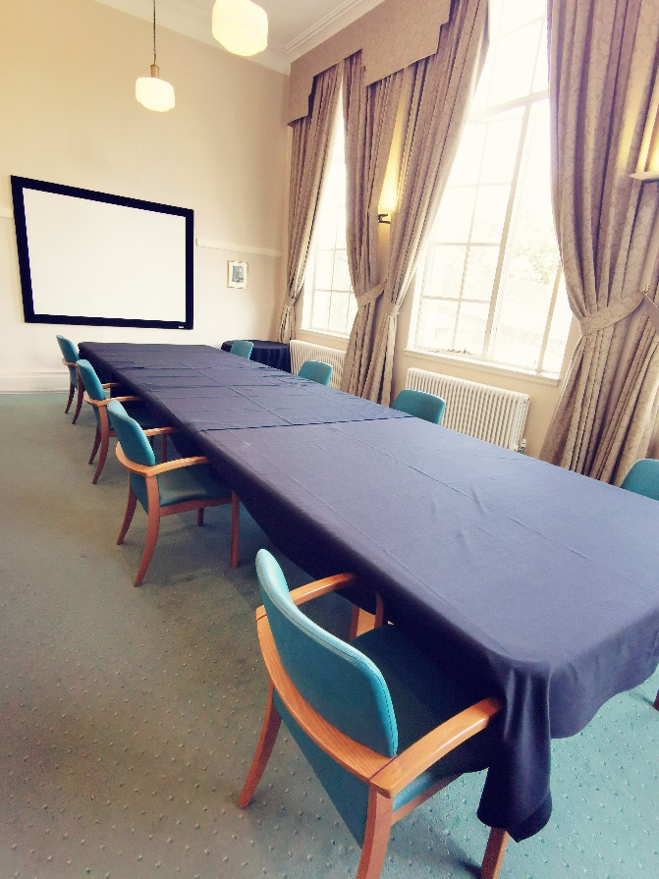

- 1sqm distancing – 8 attendees.

Garden Room

- Standard with all set ups unless otherwise stated –

- Lunch station between kitchen doors, coffee station right hand side of entrance doors. Space for distanced queuing.

- One-way entry through main doors and exit via members room foyer.

- Terraced area available and distanced to allow more space at lunch.

- Registration desk can be available in the foyer.

Theatre Style

- 2sqm distancing – 24 attendees

- 1sqm distancing – 28 attendees

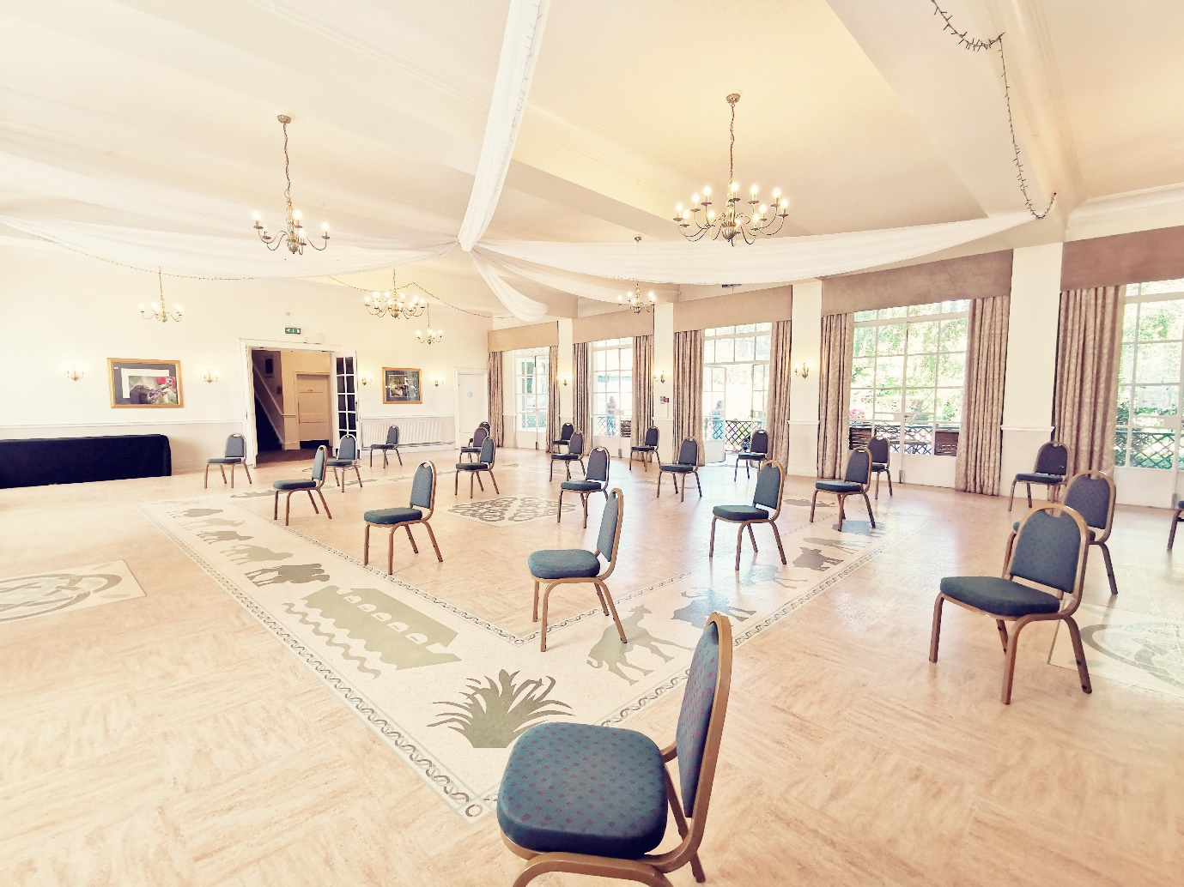
Classroom

- 2sqm distancing – 22 attendees - 2 people per table.
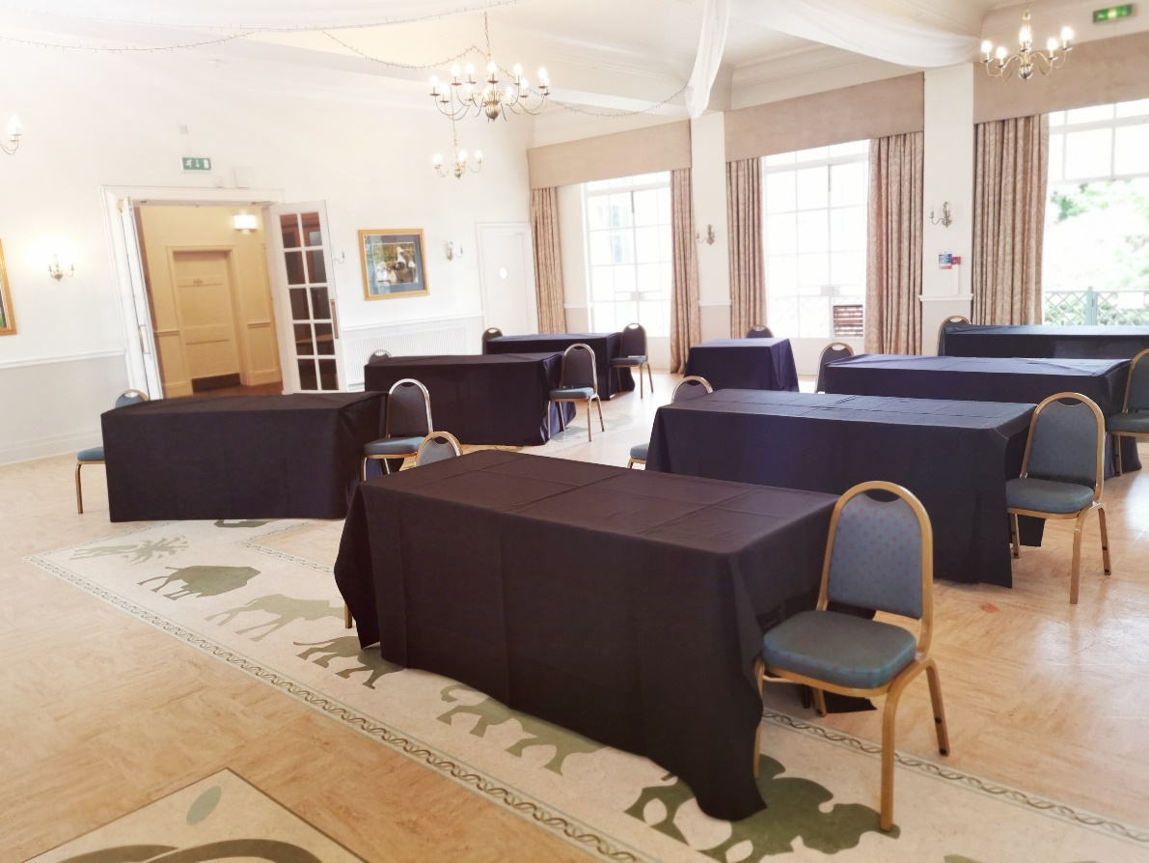

- 1sqm distancing – 32 attendees - 3 people per table.
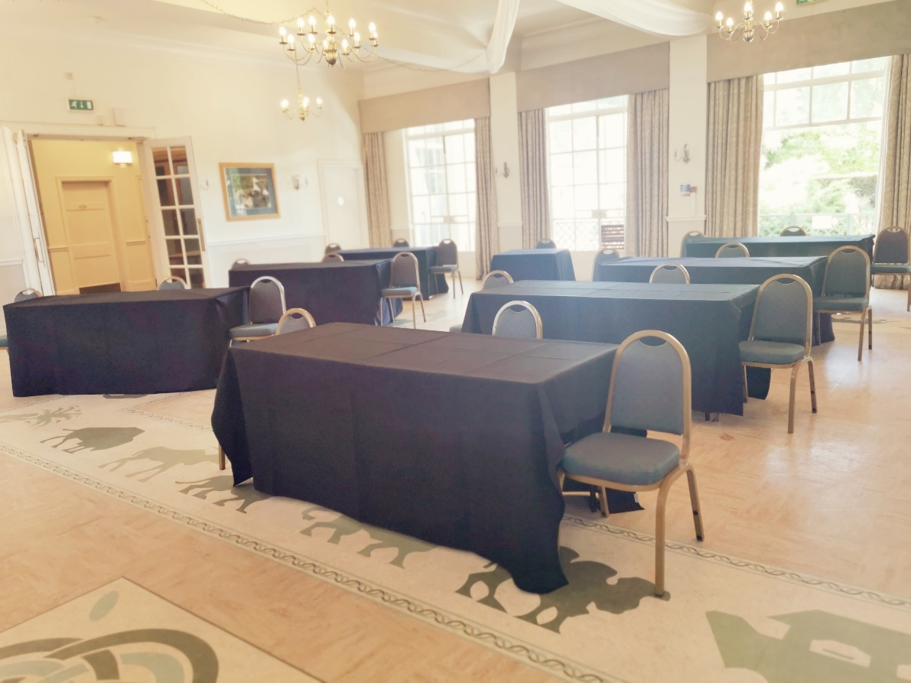

Boardroom – 8 trestle tables

- 2sqm distancing – 10 attendees – including 1 chair at front for organiser.
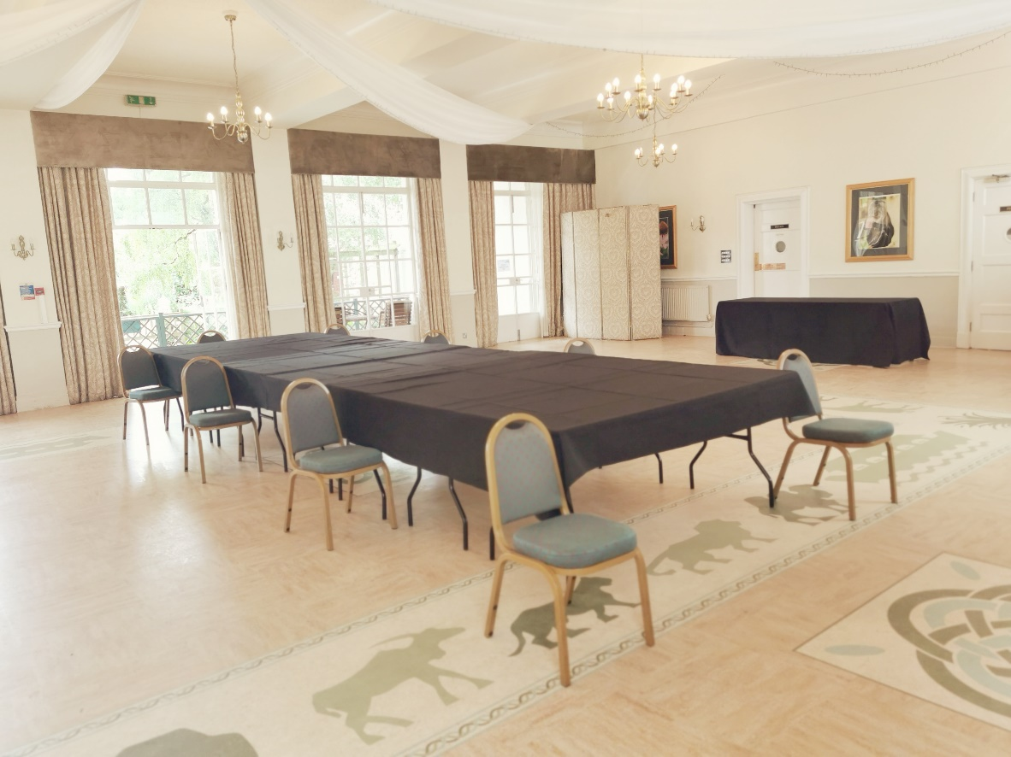

- 1sqm distancing – 14 attendees – including 1 chair at front for organiser.

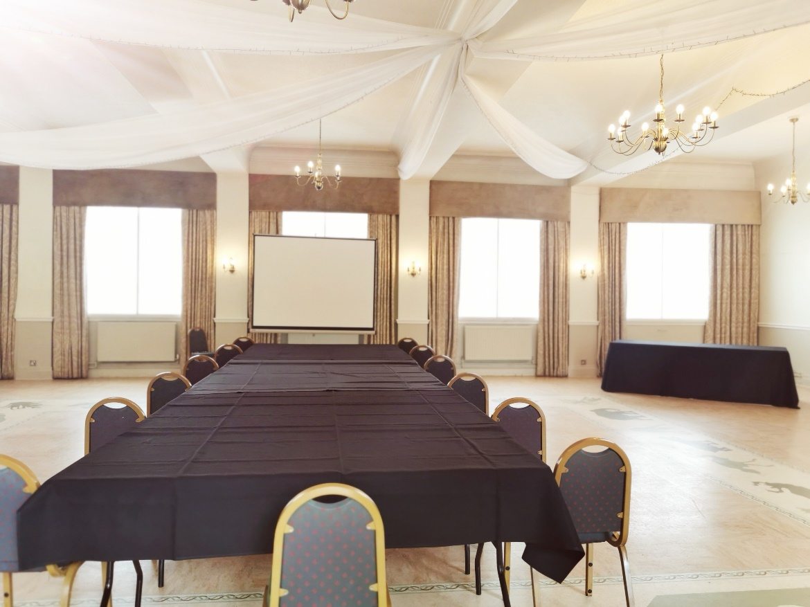

U Shape

- 2sqm distancing – 10 attendees – including 1 chair at front for organiser.

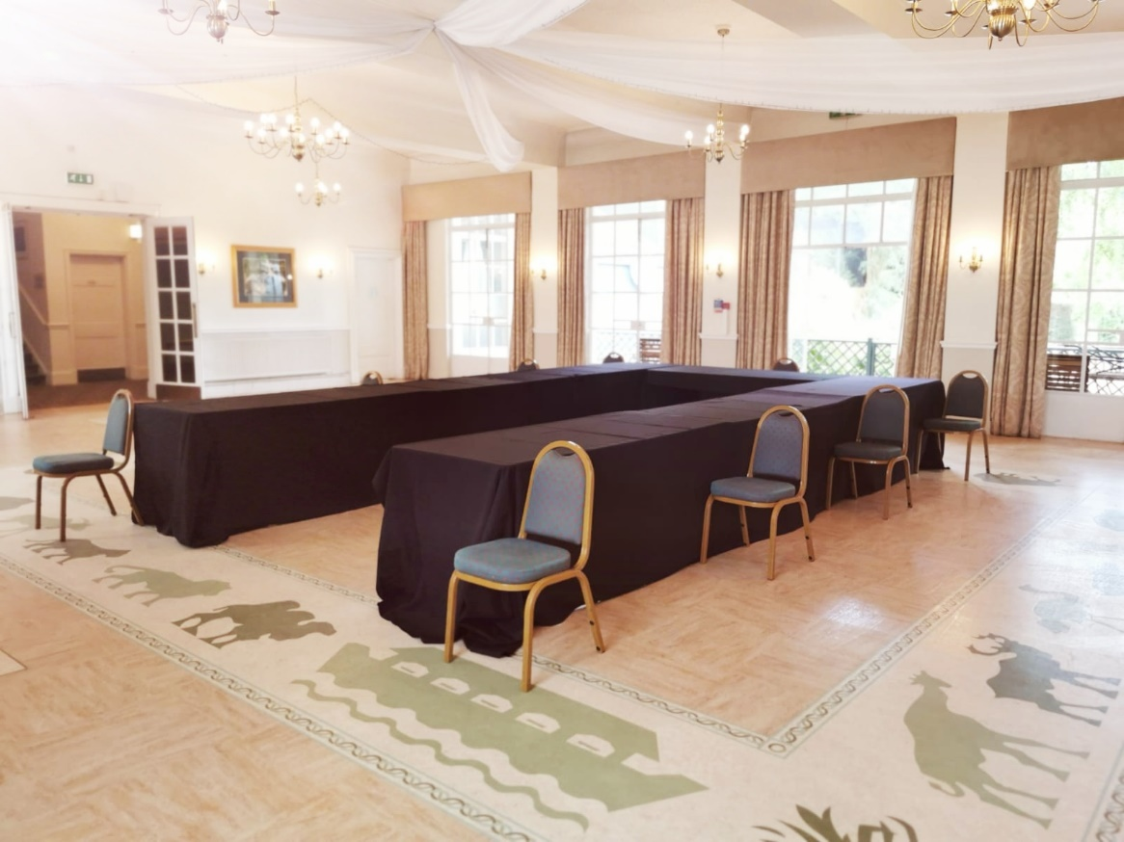

- 1sqm distancing – 13 attendees – including 1 chair at front for organiser.

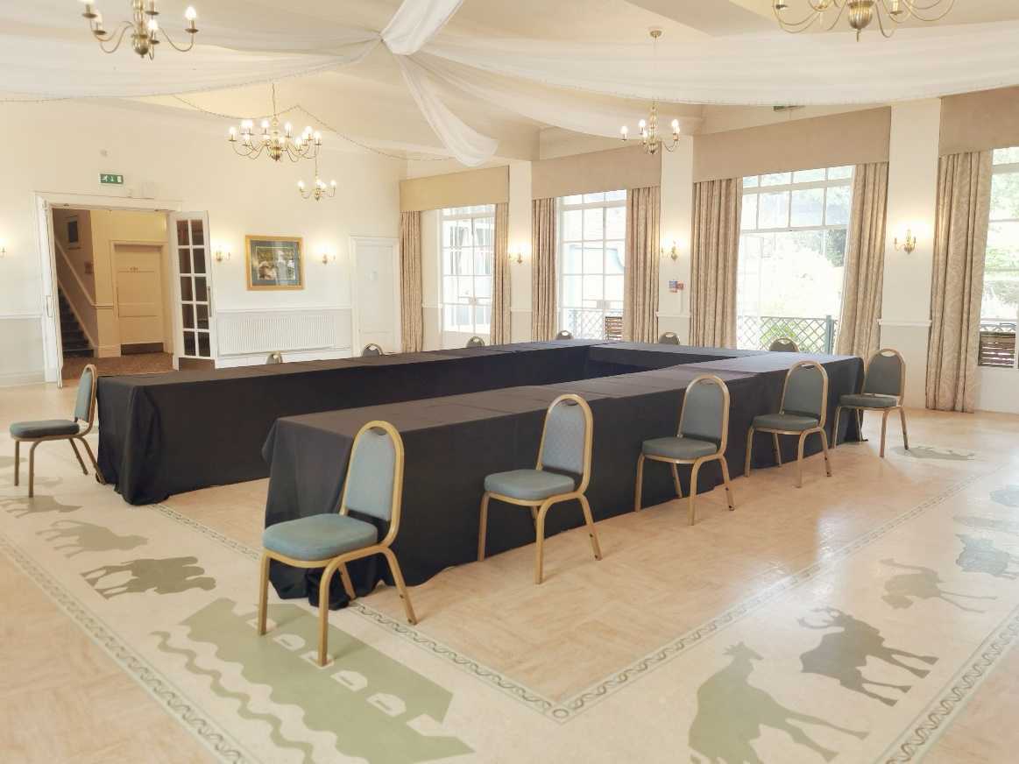

Cabaret Style – 9 round tables

- 2sqm distancing – 18 attendees.

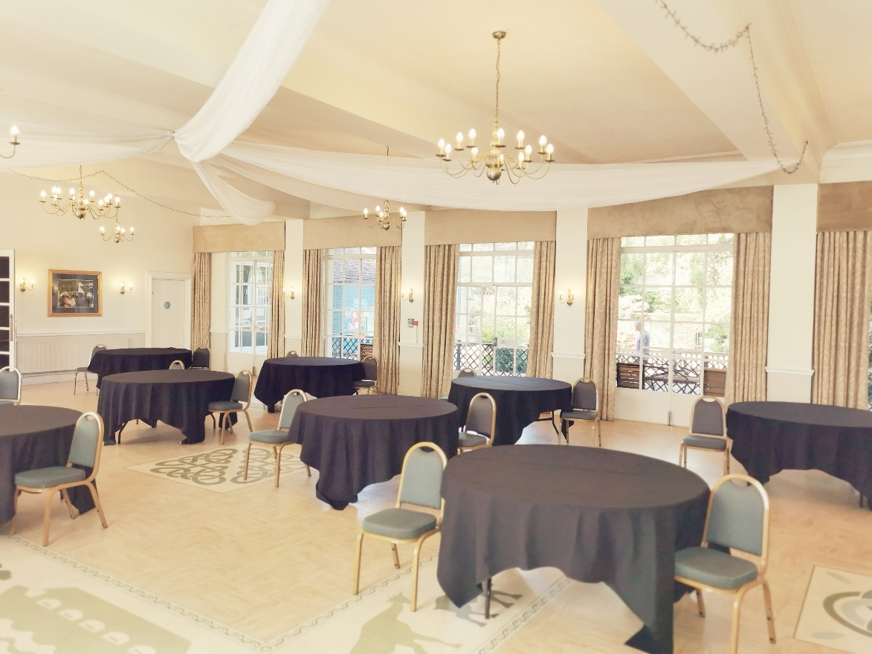

- 1sqm distancing – 27 attendees.

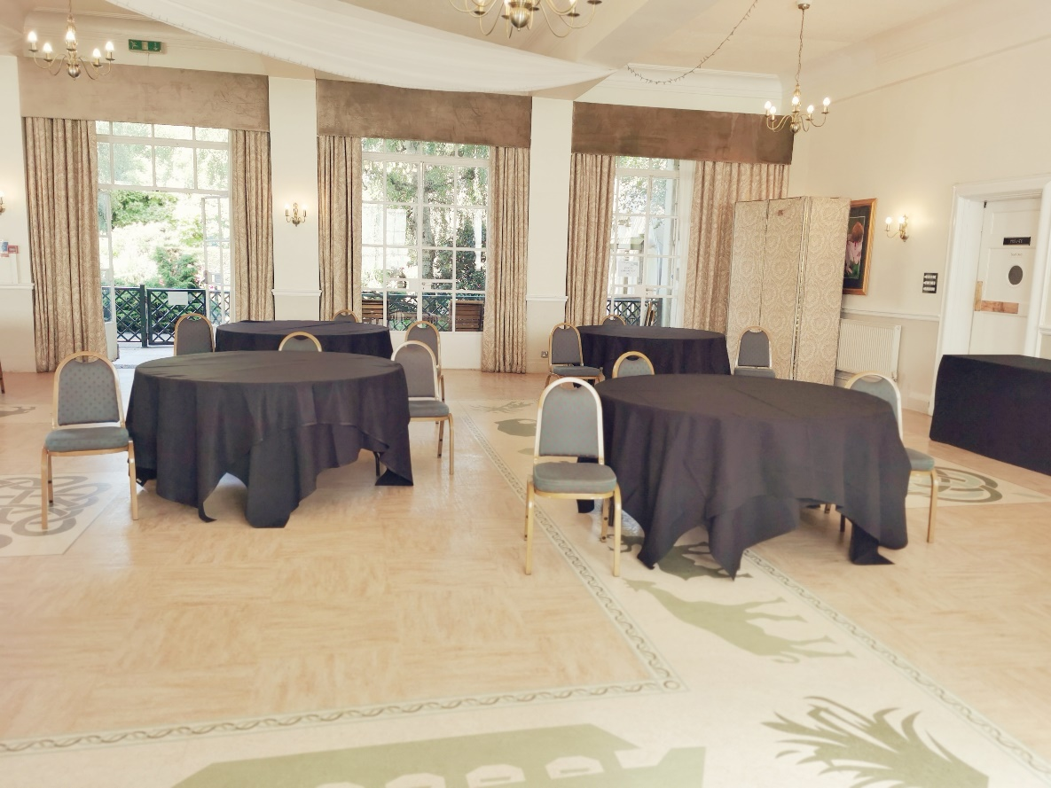

Banqueting – 9 round tables

- 2sqm distancing – 18 attendees.
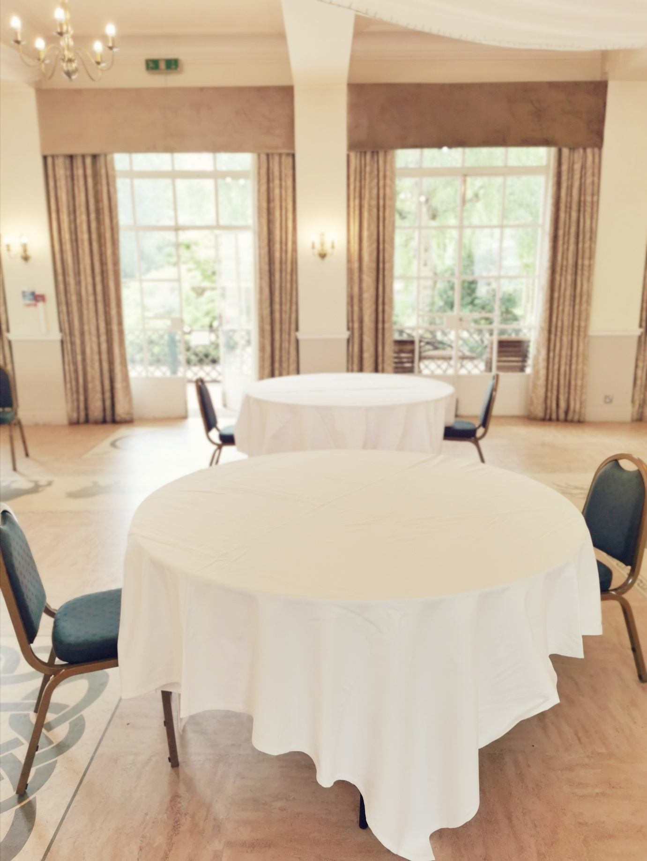

- 1sqm distancing – 27 attendees.

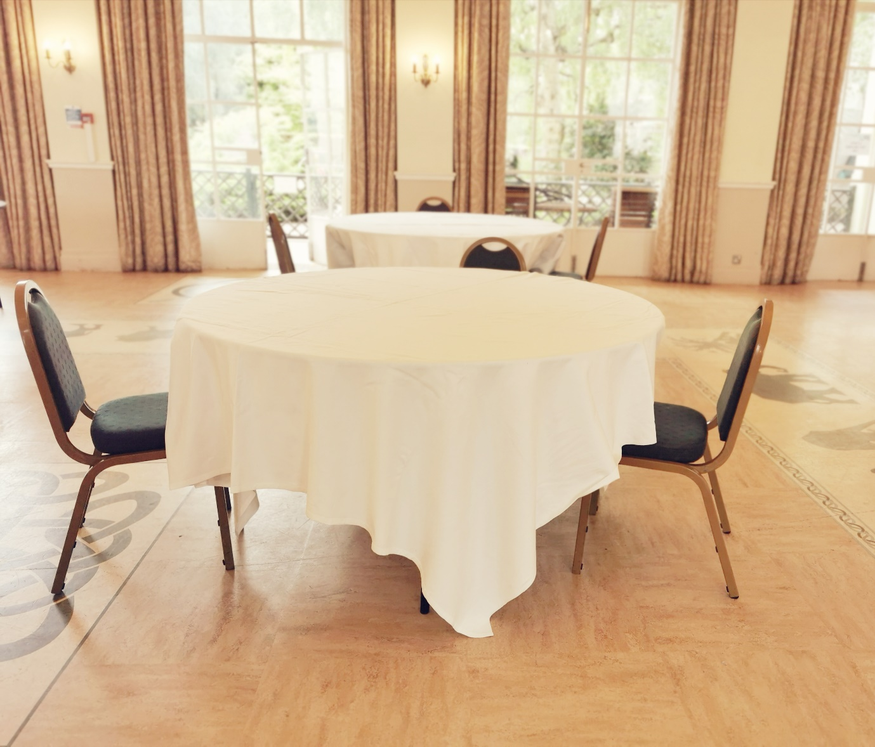

Banqueting – Family Group

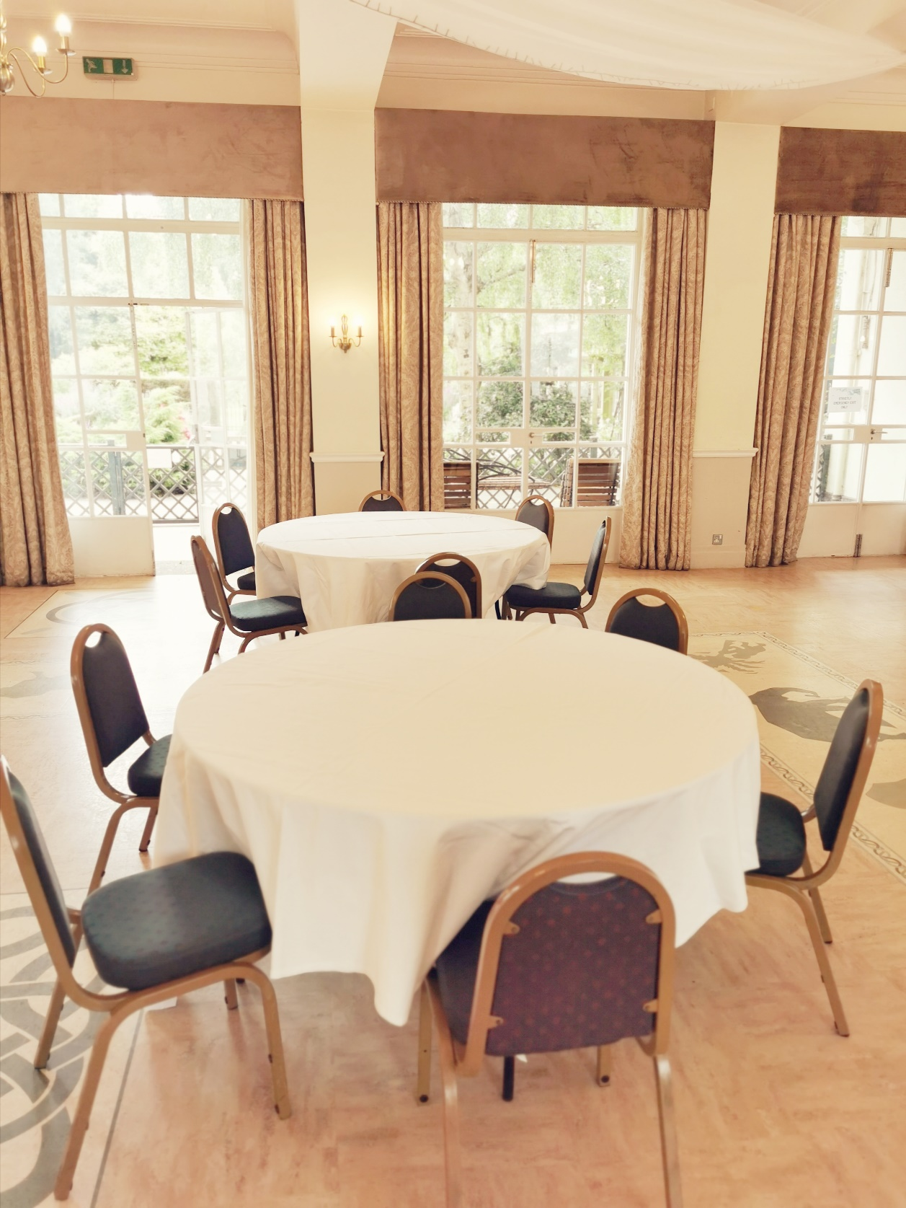
- As per the guidance a family that are living together in the same household can sit around a single table together. The images are based on 6 household members. The tables would still be distanced at 2sqm a part, taking into consideration other guests attending.

Clifton Suite

- Standard with all set ups unless otherwise stated –

- Lunch station directly outside of satellite kitchen on the right-hand side. Coffee station to the left-hand side of entrance doors. Space for distanced queuing.

- Both doors to remain open with a one way entry and exit system through the single access door.

- Terraced area to be available and distanced to allow more space at lunch.

- Registration desk can be available on the landing area.

Cabaret Style – 9 round tables

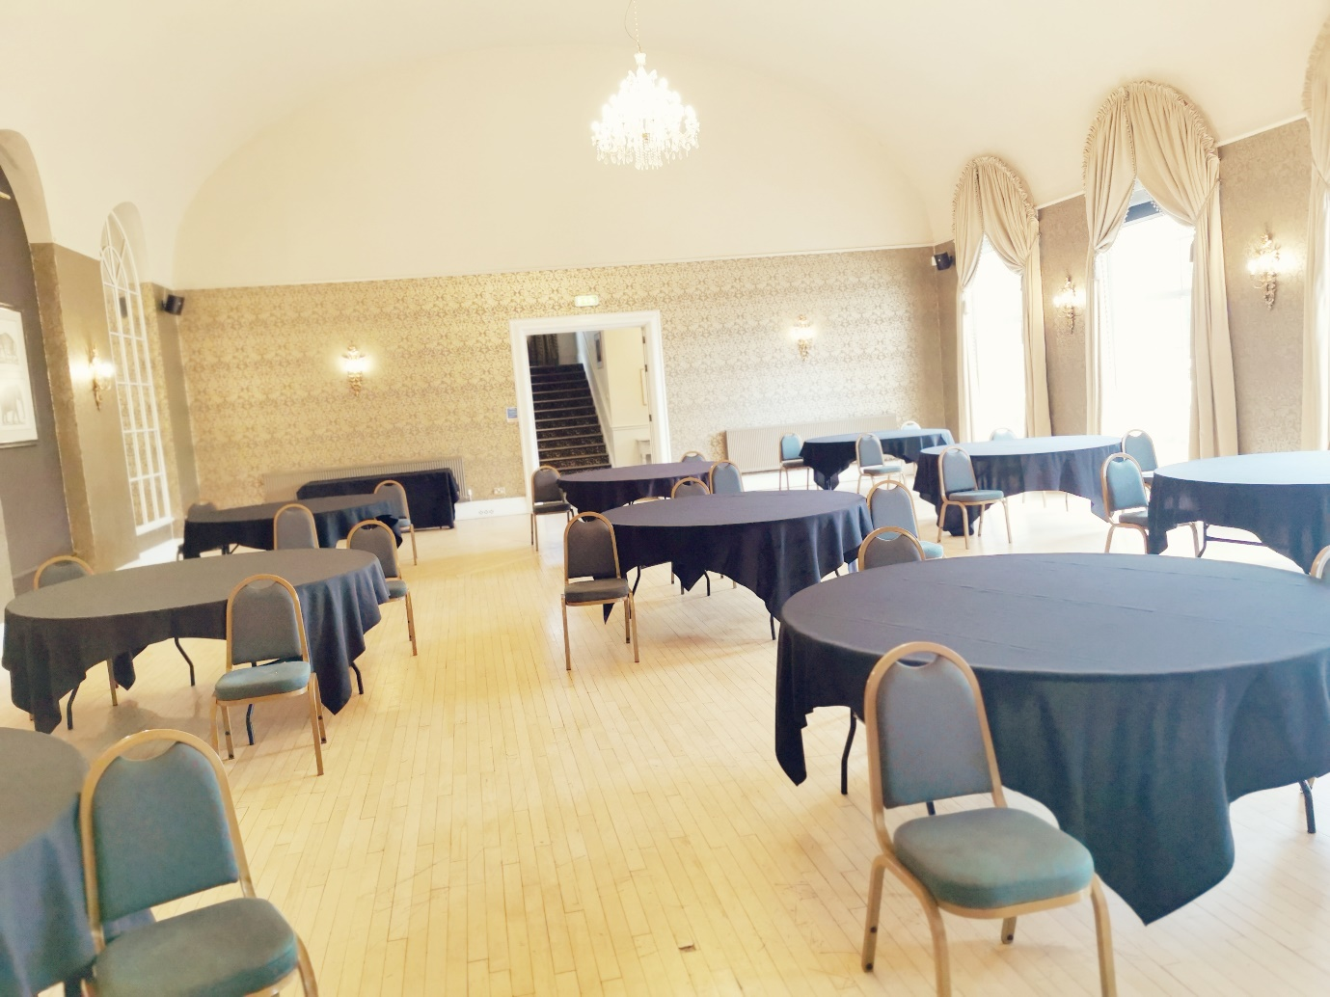
- 2sqm distancing – 27 attendees.

- 1sqm distancing – 36 attendees.

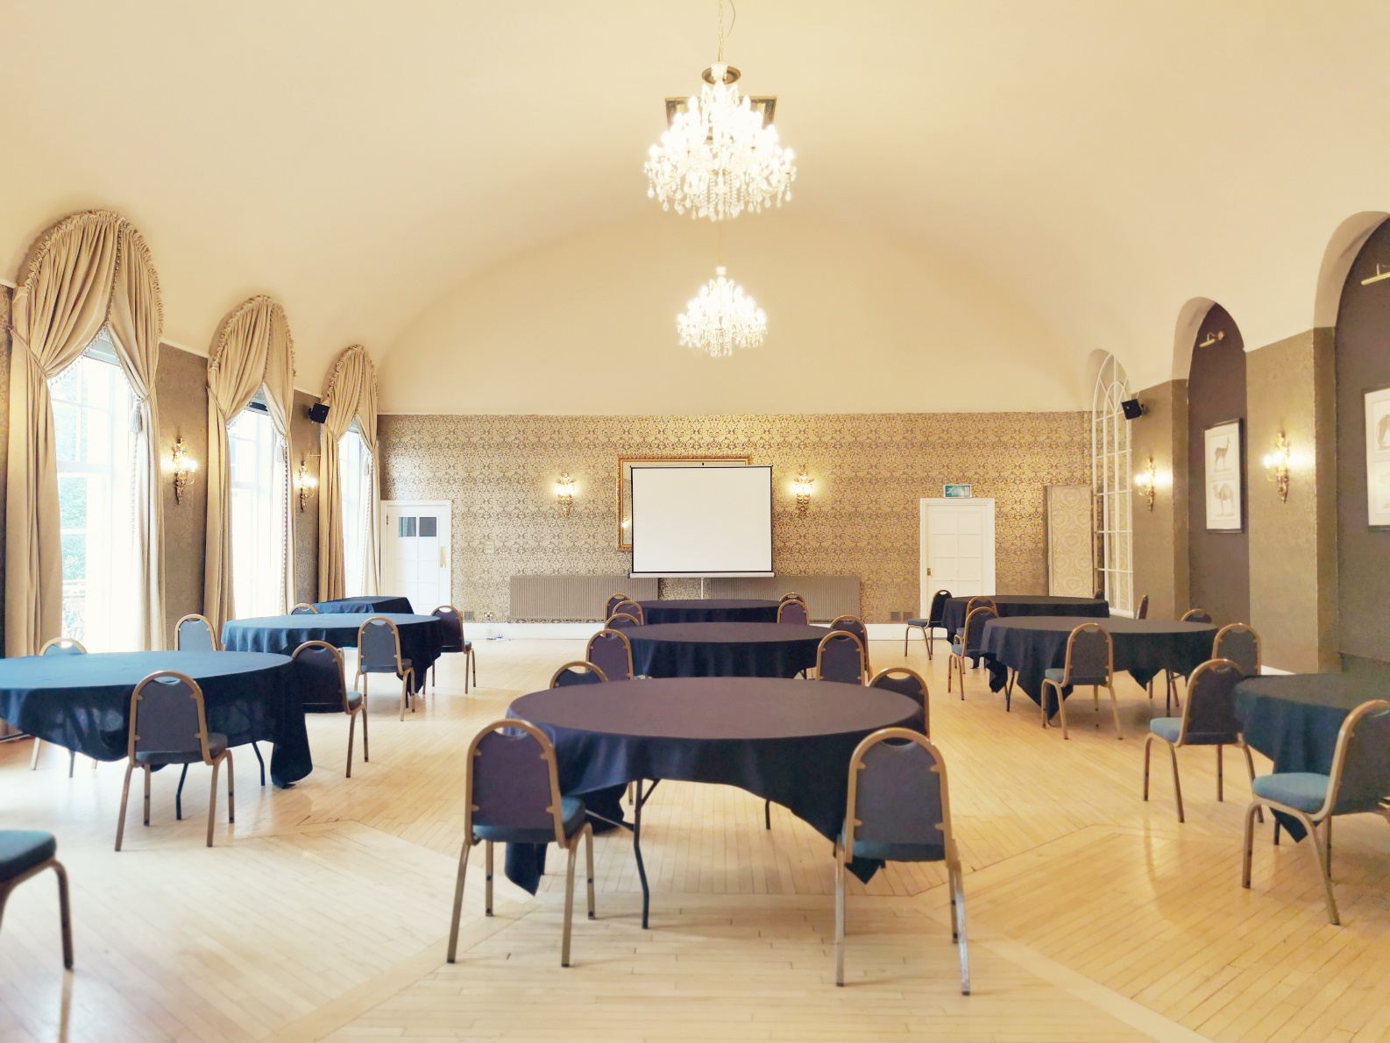

Banqueting – 9 round tables

- 2sqm distancing – 27 attendees.
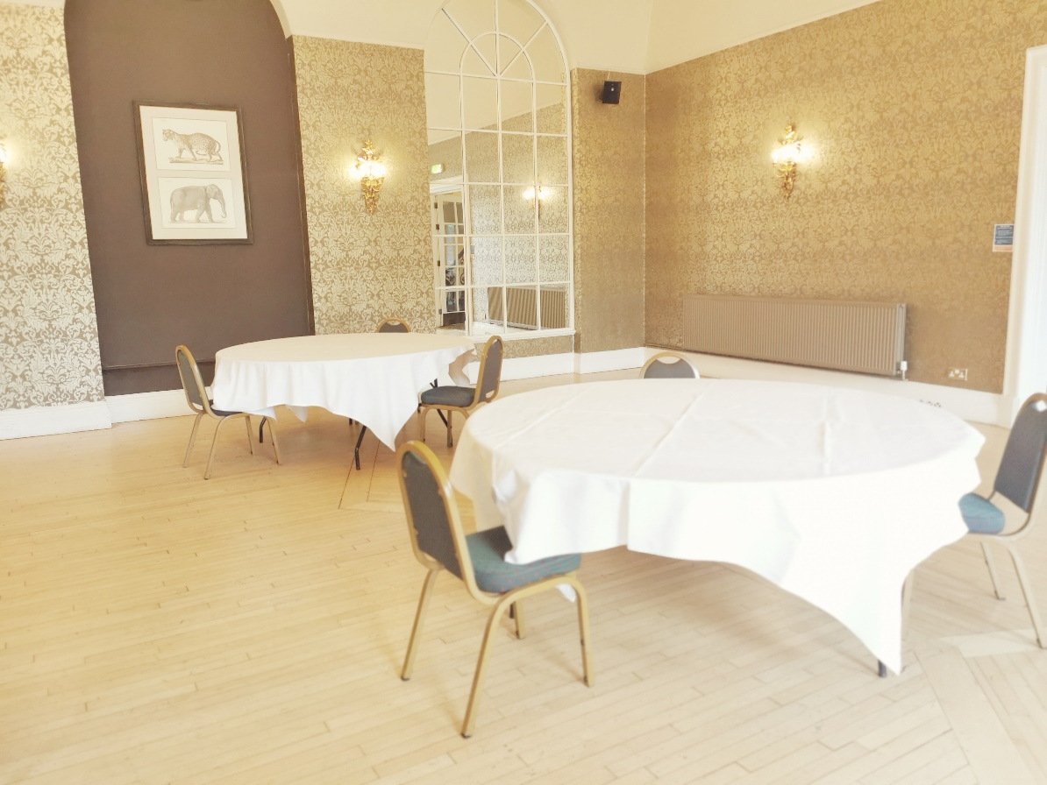

- 1sqm distancing – 36 attendees.

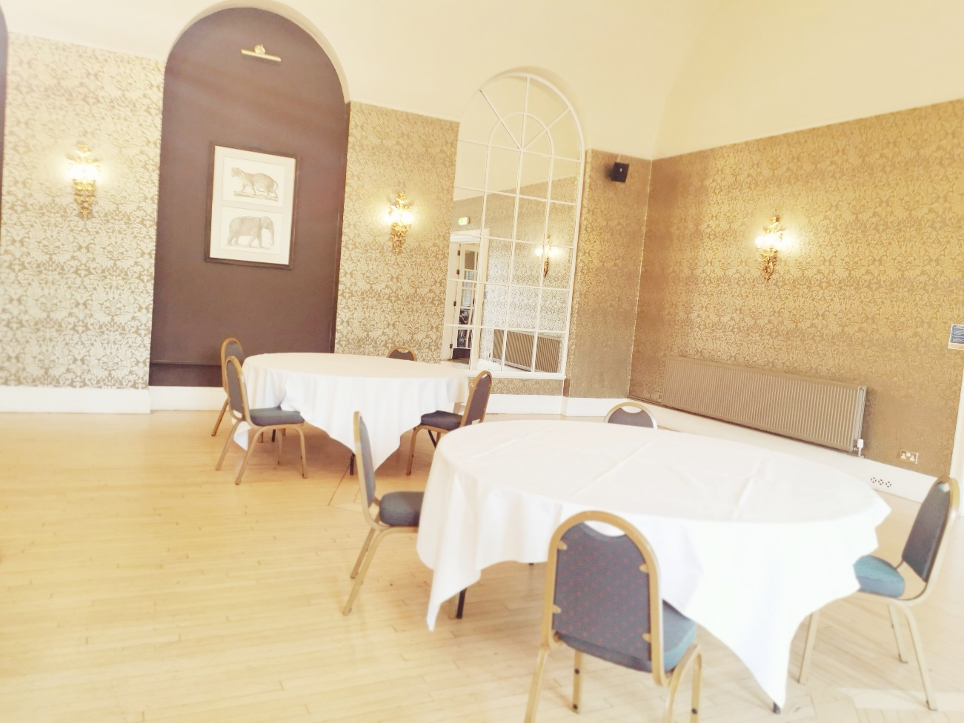

Wedding’s

Ceremony

- Registrars table at far left of the room by the kitchen doors.

- Couples table in front of the mirror.

- Aisle is 2sqm distanced (also allowing the bride room!)

- Chairs start a little further back to accommodate an extra couple of guests.

- Guest numbers are not inclusive of the couple who will be stood/sat at the front of the room and the 2 registrars on their table to the side.

- Whole room photo – 2sqm on the left and 1sqm distancing on the right.

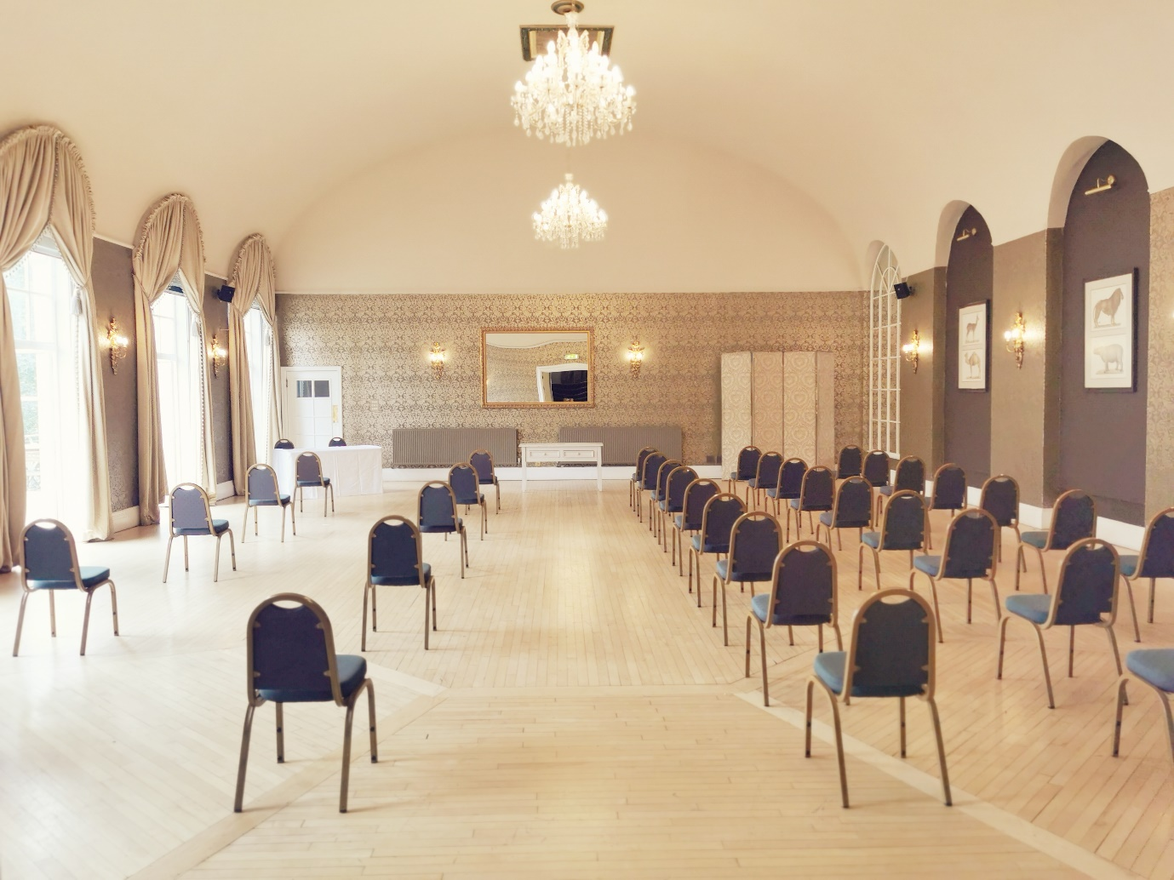
- 2sqm distancing – 10 guests per side, 2 rows of 5 - 20 in total.

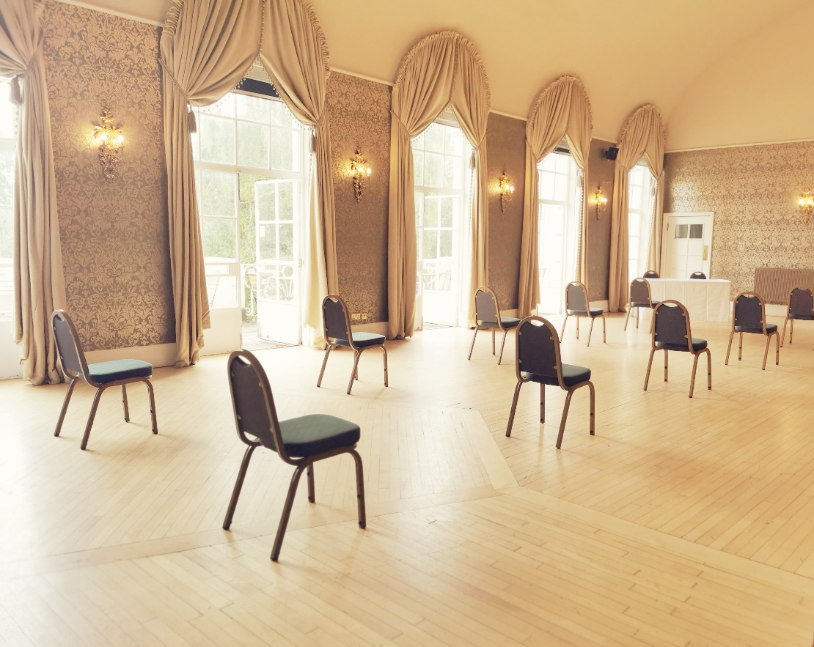

- 1sqm distancing – 27 guests per side, 9 rows of 3 - 54 in total.

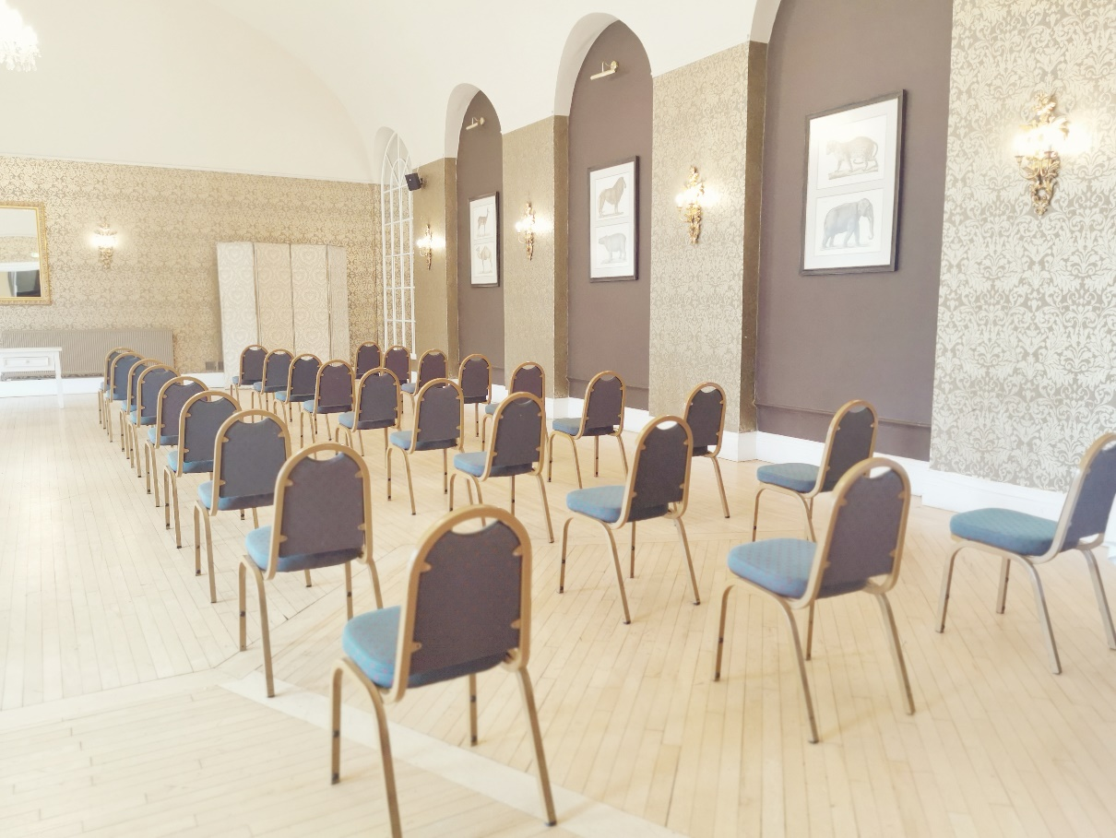

Wedding Breakfast – 9 round tables

- 2sqm distancing – 27 attendees.

- 1sqm distancing – 36 attendees.

Wedding Breakfast – Family Group

- As per the guidance a family that are living together in the same household can sit around a single table together. The image is based on 6 household members. The tables would still be distanced at 2sqm a part, taking into consideration other guests attending.

